REVISED DIAGRAMS

USE-CASE DIAGRAM

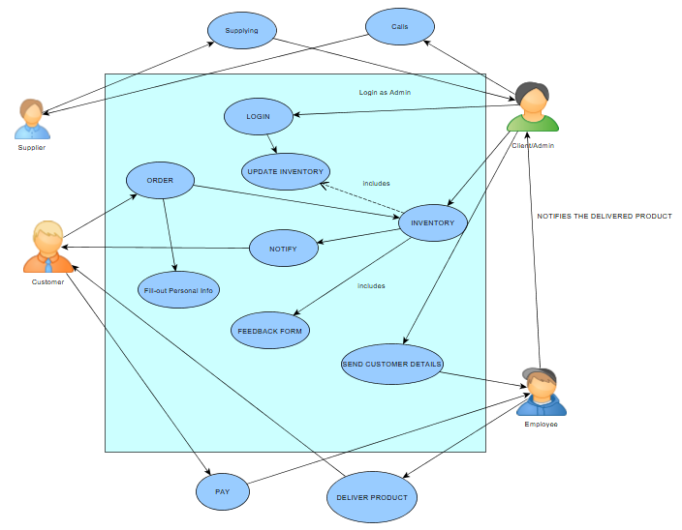

ERD (ENTITY RELATIONSHIP DIAGRAMS

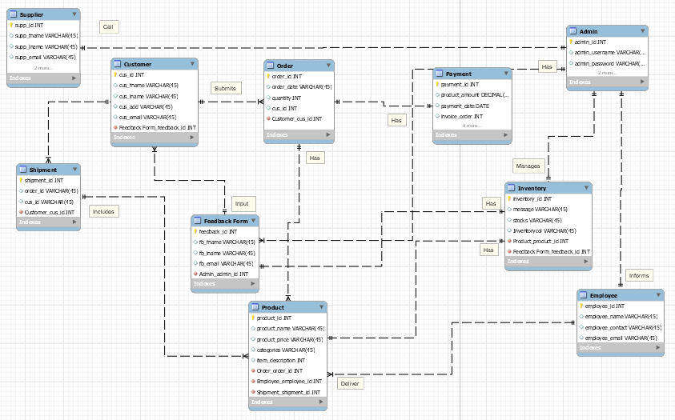

DATA FLOW DIAGRAM

FUNCTIONAL DECOMPOSITION DIAGRAM

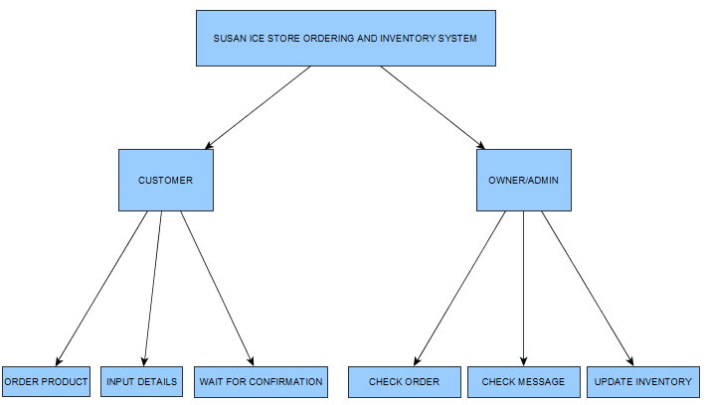

ACTIVITY DIAGRAM

CUSTOMER USING WEBSITE

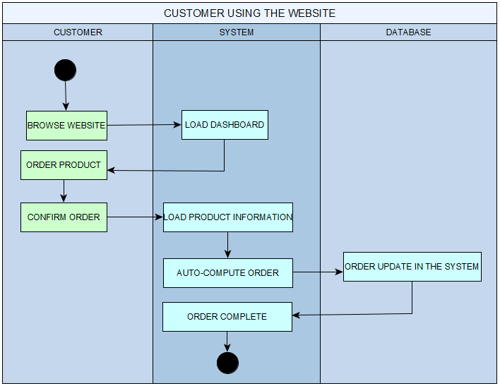

ADMIN USING THE WEBSITE

